To gain hands-on experience in using forensic tools to recover deleted files from various storage media, analyse the recovered data, and document findings in a comprehensive report.

Storage media assessed: USB Flash drive(capacity 32GB),FAT32 file system

Tools used: Photorec

Task 1: Preparation

◦ Document the storage media type, capacity, and any visible characteristics.

◦ Create a hash of the storage media to ensure data integrity

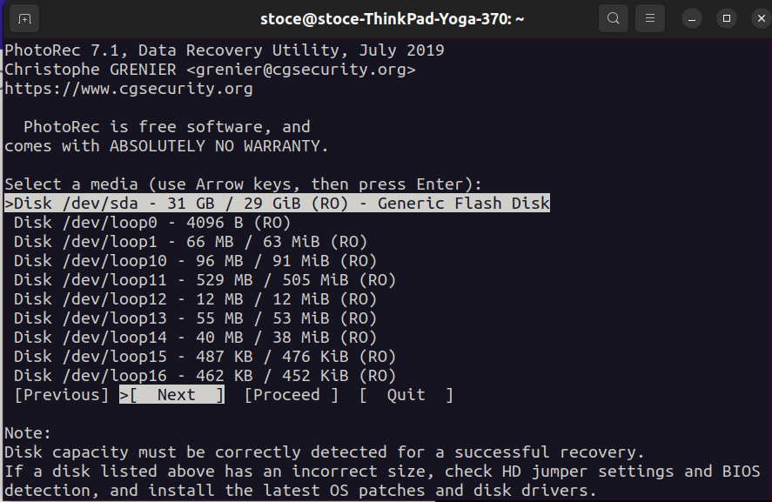

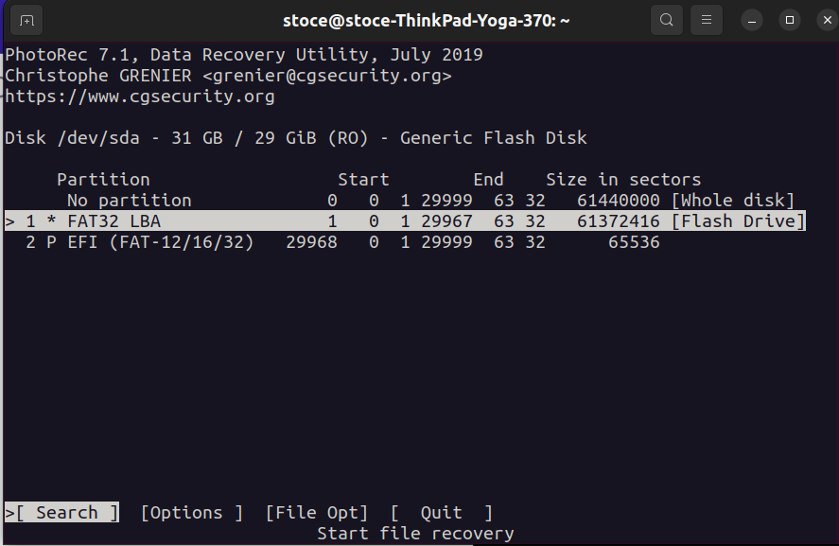

Select file system type where the files were stored(FlashDrive FileSystem)

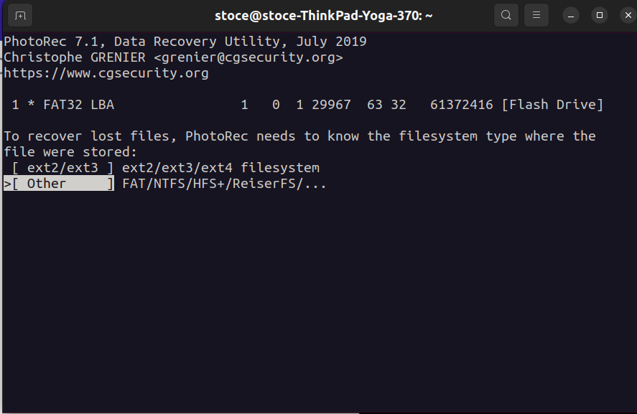

**Task 2: Creating a Forensic Image:**

* + Use FTK Imager or EnCase to create a forensic image of the storage media.
  + Verify the integrity of the forensic image using hash values.
  + 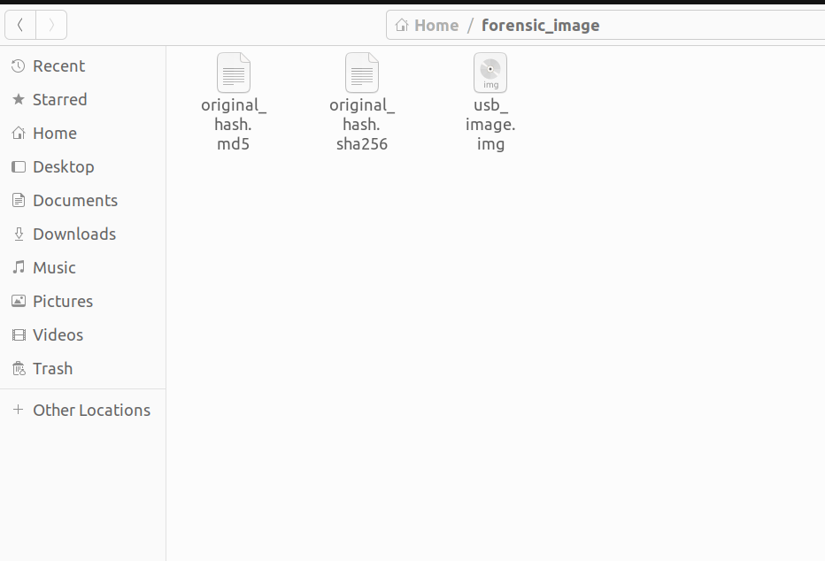
  + **Task 3: Data Recovery**

Select destination to recover files

* + 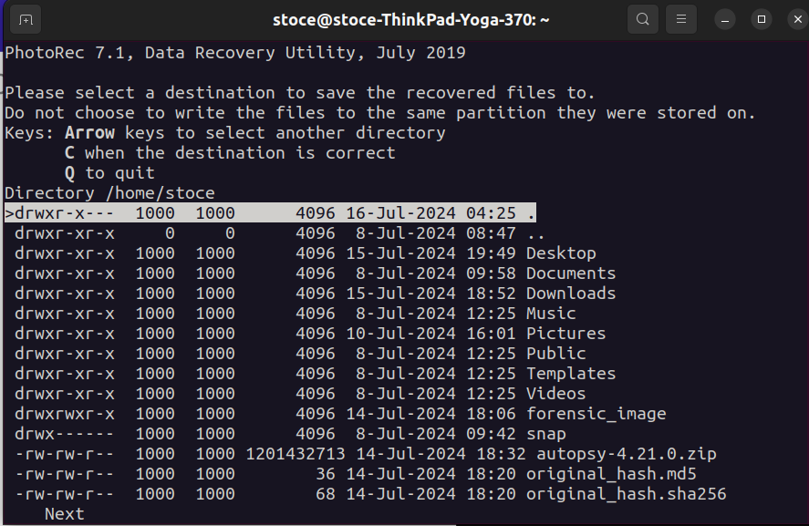

File destination is specified, one can also copy the usb image.img from the forensic image collected on a different location to get the recovered data

* + 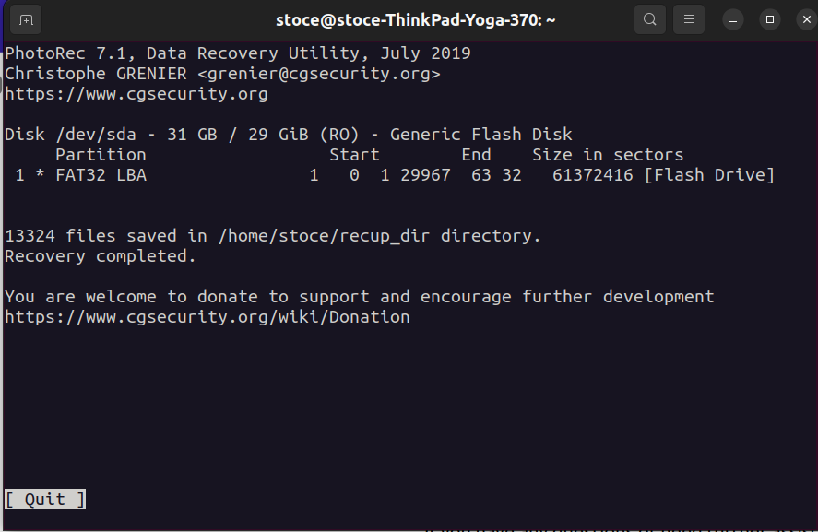

**Task 4: Data Analysis**

1. **File Analysis:**

Since we have the devices we need, we restore the disk image, to analyze the data restored

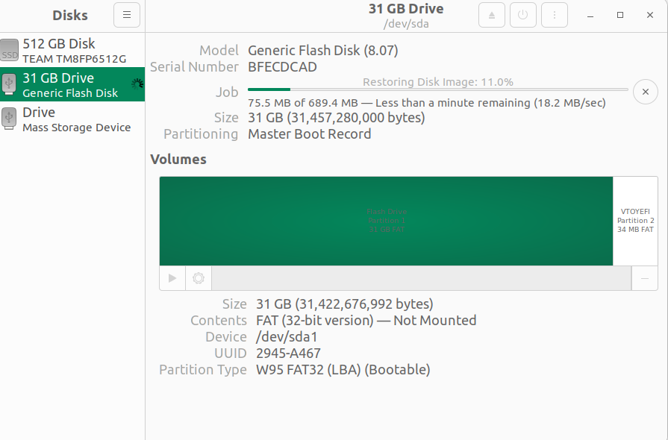

The flashdrive was in bootable mode and shows the OS that was on the drive.



**Task 5: Summary**

**Device summary:**

**Device**: /dev/sda

**Size**: 32 GB (29 GB)

**Type**: Generic Flash Disk

**Partition**: FAT32 LBA

**Sector Range**: 0 - 29967

**Recovery Outcome**:

**Number of Files Recovered**: 13,324

**Recovery Directory**: /home/stoce/recup_dir

**Completion Status**: Recovery completed successfully.

**Recovery Directory Selection:**

**Directory Selected**: /home/stoce

**Filesystem Identification**

**Filesystem Type**:

**Selected Type**: Other

**Supported Types**: FAT/NTFS/HFS+/ReiserFS, among others.